**INTERNSHIP REPORT**

**ON**

**TAMILNADU RAINFALL ANALYSIS**

## REGIONAL METEOROLOGICAL CENTRE

## INDIA METEOROLOGICAL DEPARTMENT

## CHENNAI 600 006

**SUBMITTED TO**

## PRESIDENCY COLLEGE (AUTONOMOUS)

## DEPARTMENT OF STATISTICS

## MASTER OF SCIENCE

**BY**

## RAKESH D (2113212075007)

## SADISH P (2113212075008)

## SESHASAI B (2113212075010)

## NANDHINI K (2113212075023)

## LOKESHWARI M (2113212075022)

# 

# 

# **DECLARATION**

We hereby declare that the report entitled “**TAMILNADU** **RAINFALL ANALYSIS**” submitted in partial fulfilment of the requirement for the award of Degree of Master of Science in Statistics for the year 2022-2023 is based on the original work done by us under the guidance and supervision of **Dr. B. Geetha,** Director/Scientist-D, Regional Meteorological Centre, Chennai.

## RAKESH D LOKESHWARI M

## (2113212075007) (2113212075022)

## SADISH P NANDHINI K

## (2113212075008) (2113212075023)

## SESHASAI B

## (2113212075010)

# **ACKNOWLEDGEMENT**

Our sincere thanks to **Dr. S. Balachandran**, **Head/Scientist-F,** Deputy Director General of Meteorology, Regional Meteorological Centre, Chennai for permitting us to carry out Internship at RMC, Chennai. We would like to thank our guide **Dr. B. Geetha, Scientist-D** Regional Meteorological Centre, Chennai for their co-operation and extensive support and we would like to thank **Ms. R. V. Deepa, Scientific Assistant,** RMC Chennai and

**Shri. Yagya Priya Mourya, Scientific Assistant,** RMC Chennaifor their support and sincere guidance throughout the internship program. Without them this internship would not have been possible.

I would like to thank **Dr. R. Raman,** Principal, Presidency College (Autonomous) and **Dr.N.VISWANATHAN,** Head, Department of Statistics, Presidency College, for giving us this greatest opportunity to have an internship training course in curriculum. Our special regards to Professors **Dr. P. R. Jayashree, Dr**. **Nancy** **Leisley**, **Tmt. R. Renukadevi , Dr**. **R. Sakthivel, Dr. R. K. Radha, Dr. M. Thilagam** and **Tmt. D. Sarala** for their support and enlightenment. We would like to thank everybody who directly and indirectly helped us in completing this internship successfully.

# 

# **CERTIFICATE**

This is to certify that the internship entitled "***TAMILNADU*** ***RAINFALL ANALYSIS***" submitted by

**RAKESH D (2113212075007),**

**SADISH P (2113212075007),**

**SESHASAI B (2113212075010),**

**LOKESHWARI M (2113212075022),**

**NANDHINI K (2113212075023)**

M.Sc. Statistics, Department of Statistics, Presidency College (Autonomous), Chennai, done during the summer internship at Regional Meteorological Centre for the year 2022 is a Bonafide work carried out under our supervision and guidance during the period (18/07/2022 to 30/08/2022).

## External Guide,

## Dr. B. Geetha,

**Director / Scientist-D,**

**Regional Meteorological Centre,**

**Chennai-06.**

|  |  |  |
| --- | --- | --- |
| Unit | Context | Pg. No. |
| **1** | **INTRODUCTION** | **1** |
| **1.1** | About | 1 |
| **1.2** | Primitive history of RMC Chennai | 3 |
| **1.3** | Mandates of IMD | 4 |
| **1.4** | Role of RMC Chennai | 5 |
| **1.5** | Aspiration of long-range forecasting | 6 |
| **2** | **CLIMATOLOGY** | **8** |
| **2.1** | Humidity | 10 |
| **2.2** | Temperature | 10 |
| **2.3** | Wind Velocity | 10 |
| **3** | **RAINFALL** | **11** |
| **3.1** | Rain gauge | 11 |
| **3.2** | Rainfall in Tamil Nadu | 12 |
| **3.3** | South-West Monsoon | 13 |
| **3.4** | North-East Monsoon | 14 |
| **4** | **PRESENT STUDY** | **15** |
| **4.1** | About Data | 15 |
| **4.2** | R Programming | 16 |
| **4.3** | R Shiny Dashboard | 18 |
| **4.4** | R code | 21 |
| **5** | **ANALYSIS OF VARIANCE** | **27** |
| **5.1** | ANOVA test | 28 |
| **5.2** | Post Hoc Test (Turkey’s HSD Test) | 29 |
| **6** | **SHINY DASHBOARD APPEARANCE** | **31** |
| **7** | **INTERNSHIP STUDY** | **38** |

***INTRODUCTION***

The **India Meteorological Department** (**IMD**) is an agency of the [Ministry of Earth Sciences](https://en.wikipedia.org/wiki/Ministry_of_Earth_Sciences) of the [**Government of India**](https://en.wikipedia.org/wiki/Government_of_India)**.** It is the principal nodal agency responsible for [meteorological](https://en.wikipedia.org/wiki/Meteorological) observations, [weather forecasting](https://en.wikipedia.org/wiki/Weather_forecasting)and [seismology](https://en.wikipedia.org/wiki/Seismology). IMD is headquartered in [Delhi](https://en.wikipedia.org/wiki/Delhi) and operates hundreds of observation stations across India and Antarctica. Regional offices are at [Chennai](https://en.wikipedia.org/wiki/Chennai), [Mumbai](https://en.wikipedia.org/wiki/Mumbai), [Kolkata](https://en.wikipedia.org/wiki/Kolkata), [Nagpur](https://en.wikipedia.org/wiki/Nagpur), [Guwahati](https://en.wikipedia.org/wiki/Guwahati)and [New Delhi](https://en.wikipedia.org/wiki/New_Delhi).

**Regional Meteorology Centre** (RMC), Chennai was established on 1st April 1945. As of now, it is one of the six such RMCs of Indian Meteorological Department, headed by an officer of the rank of Scientist-F and Deputy Director General of Meteorology.

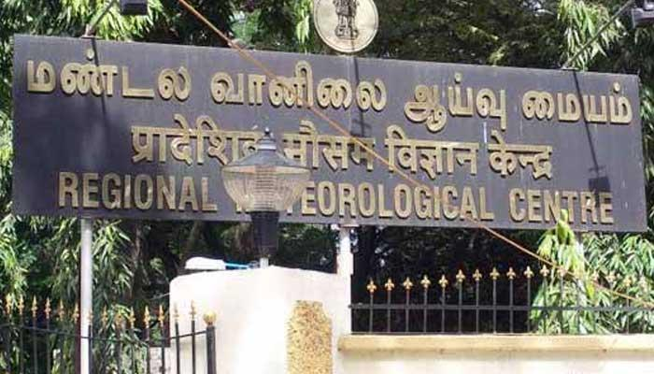

The Meteorological observatory functioning at Nungambakkam, Chennai which was formerly known as Madras (13 04'N/80 15'E).

The Regional Meteorological Centre (RMC), Chennai one of the six regional centres of India Meteorological Department (IMD), located at No. 6 (Old No.50), College Road, between Good Shepherd School and Women's Christian College. IMD is the National weather service provider for India.

The three Meteorological Centres in South India function at Hyderabad, Amaravati, Bengaluru and Thiruvananthapuram serving the states of Telangana, Andhra Pradesh, Karnataka, and Kerala &Lakshadweep respectively, under the technical and administrative control of the Regional Meteorological Centre, Chennai.

The administrative region under RMC Chennai is shown in Figure along with the locations of the surface meteorological observatories.

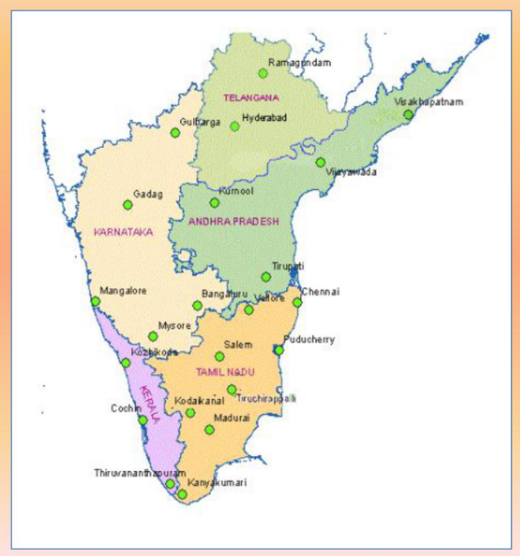

There are also Port Meteorological offices at Chennai, Kochi and Visakhapatnam, which interact with masters of ships and shipping companies and other marine interests.

More than 1,400 personnel including 300 officers work in various offices under Regional Meteorological Centre, Chennai which includes 4 meteorological centres, 1 Area Cyclone warning centre, 2 cyclone warning centres, 6 Doppler Weather Radar stations and 17 Aviation Meteorological Offices (AMOs).

**PRIMITIVE HISTORY RMC CHENNAI:**

The Meteorological observatory has historical importance. The Madras Observatory was established in the year 1792 ***“for promoting the knowledge of Astronomy, Geography and Navigation*** ***in India”,*** marking the beginning of the history of Regional Meteorological Centre, Chennai by Sir Charles Oakeley.

Systematic Meteorological observations in Chennai started much earlier than the actual establishment of the India Meteorological Department in 1875. The city is home to one of the first modern astronomical and meteorological observatory in the East, established at Egmore before 1792.

The 15-feet tall granite pillar monument weighing 10 tons, which carried the original transit equipment, is still preserved and carries the name of the architect, Michael Topping Arch. Inscriptions in Tamil and Telugu were carved on the pillar in order that "posterity may be informed a thousand years.

In 1899, R. L. Jones, a professor of physics at the Madras Presidency College, was appointed as part-time meteorologist of the observatory.

**MANDATES OF IMD:**

* To take meteorological observations and to provide current and forecast meteorological information for optimum operation of weather-sensitive activities like agriculture, irrigation, shipping, aviation, offshore oil explorations, etc.
* To warn against severe weather phenomena like tropical cyclones, norwesters, duststorms, heavy rains and snow, cold and heat waves, etc., which cause destruction of life and property.
* To provide meteorological statistics required for agriculture, water resource management, industries, oil exploration and other nation-building activities.
* To conduct and promote research in meteorology and allied disciplines.

**FUNCTIONS OF RMC CHENNAI:**

* Taking of surface meteorological and hydrological manual observations.
* Maintenance of instruments and periodic inspection of observatories.
* Issuing public forecasts and providing warning services including cyclone warning, sea navigation and port warnings.
* Monitoring of South West monsoon and North East monsoon over the states under RMC, Chennai.
* Promote and carryout research in meteorological and allied sciences.
* Taking of Weather observations from Automatic Weather Stations (AWS).

The mandate of IMD is to provide public weather services to the people of India which broadly experiences four seasons as classified below.

* Winter season: (January, February)

Mostly this is early summer season.

* Pre-monsoon season: (March – May)

Summer season all over India

* Monsoon season / Southwest monsoon season: (June-September)

Mostly this occurs in the rainy season

* Post-monsoon / Northeast monsoon season: (October- December)

Likely known as post rainy season or spring season.

India’s economy and hence agriculture depends on SWM seasonal rainfall. Hence meteorologists have been making efforts to forecast the performance of the Indian summer monsoon which is also known to be South West Monsoon (SWM), sufficiently based on statistical computations dependent on several atmospheric parameters.

**MAIN ASPIRATION OF LONG RANGE FORCASTING:**

India being an agricultural country the water scarcity and gain-loss in crop production in every year is faced with great concern.

High portion of annual rainfall in India is received during the South West Monsoon (SWM) season during June-September. However, this small fluctuation in the seasonal rainfall can have devastating impacts on India’s economy.

**LONG RANGE FORECASTING IN INDIA:**

The India Meteorological Department (IMD) has been issuing long-range forecasts (LRF) based on statistical methods for the southwest monsoon rainfall over India (ISMR) for more than 100 years. The recent two droughts, 2002 and 2004 made an adverse impact on India’s economy. Therefore, long range prediction (seasonal prediction) of southwest monsoon rainfall deserves high priority in India.

* In 1988, IMD introduced the 16 parameters power regression & parametric model. IMD introduced a new two stage forecast strategy by which the first stage of forecast is issued in April and updated for the April forecast is issued in June.
* In 2007, IMD introduced new statistical forecasting system based on ensemble technique for the southwest monsoon season rainfall over the country as a whole. In the ensemble method, instead of relying on a single model, all possible models based on all the combination of predictors are considered.

IMD report the improved results of new experimental statistical models developed for LRF of southwest monsoon seasonal (June–September) rainfall. These models were developed to facilitate the IMD’s present two-stage operational forecast strategy. Models based on the ensemble multiple linear regression (MLR) and projection pursuit regression (PPR) techniques were developed to forecast the ISMR. These models used new methods of predictor selection and model development. After carrying out a detailed analysis of various global climate data sets; two predictor sets, each consisting of six predictors were selected. The new models showed better performance in their hindcast, compared to the model based on climatology and were able to provide correct forecasts of the deficient(drought) monsoon rainfall events.

***CLIMATOLOGY***

Climatology, branch of atmospheric sciences which deals with both the description of the climate and also the analysis of the climate differences and changes and consequences. It is scientific study of the climate and how it changes over time is known as the average weather conditions which is the foundation for the weather and climate forecasting.

The essential methods applied by climatologists are the **analysis of observations** and modelling of the physical processes that determine the climate. The main topics of research are the study of climate variability, mechanisms of the climate changeandmodern climate change.

Basic knowledge of climate can be used within shorter term **weather forecasting**, for instance about climatic cycles such as,

* [El Niño–Southern Oscillation](https://en.wikipedia.org/wiki/El_Ni%C3%B1o%E2%80%93Southern_Oscillation)(ENSO),
* The [Madden–Julian Oscillation](https://en.wikipedia.org/wiki/Madden%E2%80%93Julian_oscillation) (MJO),

Climate models are used for several purposes from the study of the constant change in weather. Climate system in which the estimation of the future climate is been practiced.

Weather is the state of the atmosphere in a particular place over a period of time (short period) whereas the climate is defined as the one which is the atmospheric condition that takes over a long or extended period of time.

The climate research is a very tedious process ought to it contains numerous data over a large period of time which is a complex process to evaluate and estimate for that the **differential equations** that are coupled and non-linear.

It is approximated using the numerical methods to create global climate models. Sometimes, the climate is to be modelled as **stochastic process** yet that is basically accepted as an approximation process that are otherwise too complicated to analyse.

Climatologists study both the nature of climates which includes local, regional or global and the human induced factors which cause climates to change. Climatology observes the past which helps to predict the future climate changes.

Meteorology deals with the day-to-day atmospheric conditions and their causes. Meteorology is defined as the Physics of the atmosphere. Meteorology uses the methods of Physical science to interpret and explain the atmospheric processes.

We encounter furthermore topics like humidity, temperature and so on which deals with the climatic changes. Climatic change plays the important role in the monsoon season (rainy season) which is explained and expressed in the upcoming topic.

**HUMIDITY:**

Humidity is expressed as the references the water vapour content in the air(atmosphere) which helps for the weather forecasting and it is also the factors that affect the climatic change. Humidity works in the form of the amount of water vapour in the air that influences all weather. It depends on the temperature and the pressure in the atmosphere.

**TEMPERATURE:**

Temperature is referred as the measure of the hotness or coldness with several terms of conditions in particular place of matter which indicates the flow of energy direction (from higher temperature to lower or cold temperature). Temperature is measured using the Celsius or Farhenheit scale. But the Celsius temperature scale is widely used scale in many countries and also in all branch of science.

**WIND VELOCITY:**

In meteorology, wind speed, or wind flow speed, is a fundamental atmospheric quantity caused by air moving from high to low pressure, usually due to changes in temperature. Wind speed is now commonly measured with ananemometer. Wind speed affects weather forecasting, aviation and maritime operations, construction projects etc.,

***RAINFALL***

Rainfall is **a measurement of how much water falls as rain in a certain period of time**. For example, a week or a month. Rainfall is measured by collecting rain water across different areas and times, as the amounts may differ between locations and times.

“Mawsynram”, in east Khasi hills of Meghalaya which is the wettest place in India at present, with an average annual rainfall of 11802.4 mm(average of the 1974-2022 period). “Jaisalmer”and “Leh”receive the lowest rainfall in India. These places receive less than 50 cm rainfall every year.

Rain and snow are key elements in theEarth's water cycle, which is vital to all life on Earth. The standard instrument for the measurement of rainfall is the 203mm (8 inch) rain gauge which collects the rain into a graduated and calibrated cylinder. The measuring cylinder can record up to 25mm of precipitation.

**RAIN GAUGE:**

A rain gauge is an artifact used in metrological station to help measure and collect precipitations (hydrometeors like rain, drizzle, hail, snow, and sleet, fog, etc.,) that fall in a certain place.

There are two types of rain gauges,

* Non-recording (or) ordinary rain gauge.
* Recording type (or) automatic rain gauge.

**Non-recording (or) ordinary rain gauge:**

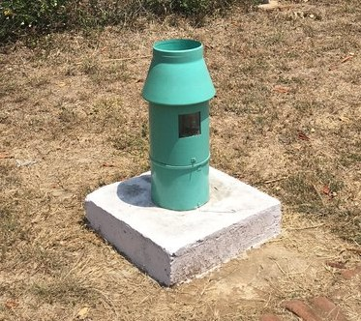

Non-recording gauges don’t record the rain but only collect the rain. Once the rain is collected, then it is measured by using a graduated cylinder.

**Recording type (or) automatic rain gauge*:***

Recording type rain gauges are those rain gauges, which can give for permanent automatic rainfall records without any bottle reading.

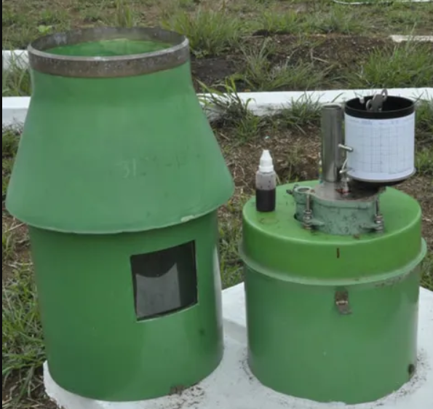In the recording gauge, it plots the rainfall against time. From that plot of data, we can easily extract the information about the intensity and duration of rainfall, on the basis of which we may make a hydrological analysis of storms.

**RAINFALL IN TAMILNADU:**

Tamilnadu is one of the states in India which receives large amount of rainfall among the other states.

A monsoon is a seasonal change in the direction of the prevailing, or strongest, winds of a region. Monsoons cause wet and dry seasons throughout much of the tropics.

Monsoon is derived from the Arabic word “MAUSIM” which means season. It refers to the seasonal reversal in the wind direction between seasons.

Monsoons are categorised into two types based on the wind direction namely,

* South-West Monsoon (SWM).
* North-East Monsoon (NEM).

**South-West Monsoon (SWM)*:***

The South-West Monsoon occurs between June-September.The districts that are benefitted by this season are Nilgiris, Kanyakumari, Western parts of Coimbatore, Dharmapuri and Salem.

The South-West Monsoon starts its downpour rain in the Western Ghats, i.e., western parts of Tamil Nadu. Most of the Eastern and Central parts of the Tamilnadu become rain shadow region in this season. In general, the amount of rainfall during South-West Monsoon decreases from west to east.

The Nilgiris district receives higher amount of annual rainfall followed by the Salem and Erode district. Kanyakumari district also receives sufficient amount of rainfall from this season.

**North-East Monsoon:**

The North-East Monsoon season occurs between October-December. The coastal and interior plains of Tamilnadu are highly benefitted by this rainy season.

Normally, the North-East Monsoon rain is associated with cyclonic formation. In this season, the amount of rainfall decreases from east to west.

Except Kanyakumari, all other interior south and western parts of Tamilnadu receives less rainfall. Coastal districts such as Chennai, Cuddalore, Tiruvallur, Kancheepuram, Villupuram, Nagapattinam, Thiruvarur and Tirunelveli districts receives heavy amount of rainfall.

***PRESENT STUDY***

Learned about IMD and RMC, Chennai, their functioning and works. About the internship we are given to make a dashboard for quick access of the rainfall data given.

**About the data:**

Our data consist of station wise daily average rainfall of Tamil Nadu over a period of 50years (1971-2020). The station wise rainfall data present in each district of Tamil Nadu is listed in the data file obtained from IMD.

For example, in Chennai District there are 3 stations namely Nungambakkam, Meenambakkam, Saidapet where the amount of rainfall is measured and recorded. Likewise, all over Tamil Nadu there were 38 Districts and 377 stations were available.

Rainfall over the area in and around those stations are being recorded for above mentioned period and composed as an average over years. If the rainfall on 1st January is given as 1mm then it is noted that it’s an average of January 1st rainfall over the period 1971-2020of that particular station in the District. Also, the data is available for all 12 months (i.e.,) for all 365 days except for February 29 which is omitted. The season wise cumulative rainfall data is provided for each station.

For example, as mentioned in earlier chapters IMD categorizes the whole year as four seasons,

* January and February as Winter
* March to May as Pre-Monsoon
* June to September as Monsoon
* October to December as Post Monsoon.

If the rainfall recorded on January 1st is 1mm then it is noted as such but for the next day (i.e.,) on January 2nd if the rainfall recorded is 0.8mm, it is noted as1.8mm (1 mm + 0.8 mm) likewise if on January 3rd the recorded rainfall is 1.2 mm, it is noted as 3.0 mm (1+0.8+1.2). This cumulative sum is continued until every season ends. For the next season the value starts fresh from zero (0).

From the data given, we are asked to make a dashboard setup so that it is easy to access the data for further study. We did our work with the help of R programming.

**R-PROGRAMMING*:***

R was created by **Ross Ihaka** and **Robert Gentleman** at the University of Auckland, New Zealand, and is currently developed by the R Development Core Team.

R is a programming language and software environment for statistical analysis, graphical representation and reporting.

The core of R is an interpreted computer language which allows branching and looping as well as modular programming using functions. R allows integration with the procedures written in the C, C++, .Net, Python or FORTRAN languages for efficiency.

The following are the important features of R,

R is a well-developed, simple and effective programming language which includes conditionals, loops, user defined recursive functions and input and output facilities.

R has an effective data handling and storage facility,

R provides a suit of operators for calculations on arrays, lists, vectors and matrices.

**R-STUDIO**:

R-Studio integrates with R as an IDE(Integrated Development Environment) to provide further functionality. RStudio combines a source code editor, build automation tools and a debugger.

For to make a dashboard appearance in R-Studio, we make use of R Shiny which is a part of R software with the help of shiny packages.

**Shiny** is a powerful and flexible R package that makes it easy to build interactive web applications and dynamic dashboards straight from R. These apps can be hosted on a standalone webpage or embedded in RMarkdown documents. Not only does shiny allow you to build these web apps from R, but it enables their construction using only R code.

Knowledge of HTMLand web development is not required at all, though it can be used to enhance your apps in numerous ways. Instructors can utilize shiny in a number of innovative and useful ways.

**About Application:**

As said earlier, our work is based on R shiny to represent the data given in dashboard to quick access it in future.

R shiny is a part of R programming. Though, it is a part it differs in coding. We use regular R functions in R shiny within particular built-in functions of R shiny. Here we have some R shiny command which are used and in creation of classic dashboard and installed recommended packages for it.

R shiny runs with 3 main parts, and explained them below one by one;

☆R code

☆UI

☆Server

In R code we have the call functions of library packages. We used several packages for our dashboard creation.

**Shiny packages:**

library(shiny)- Shiny is an R package that makes it easy to build

interactive web apps straight from R.

library(shinywidgets)- This package offers custom widgets and other

components to enhance your shiny applications

Library(janitor)-janitor has simple functions for examining and

cleaning dirty data.

Library(ggolot2)-ggplot2 is a R package dedicated to data

visualization. It can greatly improve the quality and

aesthetics of your graphics, and will make you much

more efficient in creating them.

Library(dplyr)-The dplyr package in R Programming Language is a

structure of data manipulation that provides a

uniform set of verbs, helping to resolve the most

frequent data manipulation hurdles.

Library(stringr)-Character manipulation: these functions allow you to

manipulate individual characters within the strings in

character vectors.

Library(fontawesome)-Font Awesome is the Internet's icon library

and toolkit, used by millions of designers,

developers, and content creators

After calling the required library packages, we move to set the working directory for the work made. Usually, we set the working directory because of accessing the required files and documents which are saved in local system. For this we use getwd() & setwd() function where the getwd() will give the path for current working directory and setwd() will switch the path to the desired folder.

Next, we read the data provided. As said earlier the data is converted into .csv format. So, we use read.csv function to read the loaded data in csv. The data provided for us is .txt format. Since in R we were unable to read and process the .txt effectively, we have fed the data in excel sheets for convenience and saved them as .csv format to access it later in R

After coding the required thing in R, we have moved on to user interface page. In UI page we used the function which are essential for the dashboard look needed which are explained in the upcoming.

Ui page has more page functionality. We used dashboardPage() function. It has 3 more sub sections

* dashboardheader(),
* dashboardSidebar(),
* dashboardbody().

Header position contains the header title for the application where we can use any title or any image, anything. We used logo in this section. Logo is used through the HTML tag function. tags$img function is used to link the image url from web using the source link. Then, to add something special we had a hyper link that if the logo is been clicked, it will redirect it to the IMD RMC Chennai website:

<https://mausam.imd.gov.in/chennai/>

Next, on dashboardSidebar(), we can use sidebar menu function which are needed most, we used sidebarMenu() function to declare menu items.

**About**– It is the first section which has the short description of IMD, RMC, Chennai which will be rendered in the dashboard body.

**Choose**- This section contains District filters, Station filters, date range selectors and table for the range selected. The filters are choice pickers which is used to pick the user needed District and Stations. Filtration is carried out in shiny using selectInput() function. The dateRangeInput() is used to filter the specified rainfall data over the dates selected. The table in this section renders the rainfall data for the user defined date range

**Data**- This section contains three tabs which will be displayed in the dashboard body. First tab presents the user selected station’s rainfall data in a table, second tab contains the monthly average rainfall of the Station selected and the third tab picturises the bar plot for the selected date range.

**Analysis**- In this we have the summary of the Analysis of Variance which was performed earlier in R. It will be described in later sessions. The summary will be rendered in the dashboard body.

Next, we have dashboard body where everything is displayed or rendered for the inputs given. The dashboard body has a predefined function called dashboardBody(). Every Data and table which are chosen in sidebar menu will be viewed or seen in this body. To render those we add some code functions in it.

The user interface is constructed with customized needed menus. We move on to the server page which is the main source to render the functions online (i.e), updating the ui page as the user gives input.

**Server:**

The server function is called using the shinyServer() function which has every single update and render functions inside. The server section has two parts, input and output. Each output for the desired input is rendered based on the required functions in background. For example, when the user chooses the District then, the next Station selector will filter and show only the stations of that particular District. This is carried out in coding as

observeEvent(

input$District,

updateselectInput(session,”Station”,”Station”,

choices=Data$Station[Data$District==input$Districted]

similarly, to render Data of the selected Station we use code function as

output$GivenData<-renderTable({

**<**filtered data>

})

Thus, server processes all background works of the user interface when user provides the inputs. At last to execute the application we use the code shinyApp() to combine user interface and server together. As such, we have created an application with dashboard page with all the features required by them. The output of the dashboard is shown below.

**R CODE:**

library(shiny)

library(shinydashboard)

library(shinyWidgets)

library(janitor)

library(ggplot2)

library(dplyr)

library(stringr)

library(fontawesome)

setwd("C:/Users/renugopal/Desktop/Sai")

Data<-read.csv("Data.csv")

Data1<-read.csv(file="Post_hoc.csv",T)

data <- data.frame(group = rep(c("Nungambakkam", "Saidapet", "Meenambakkam"), each = 365),values = c(Data1$Nungambakkam,Data1$Saidapet,Data1$Meenambakkam))

model <- aov(values~group, data=data)

title<-tags$a(

href='https://mausam.imd.gov.in/chennai/',

tags$img(

src="https://newsonair.gov.in/writereaddata/News_Pictures/NAT/2018/Nov/NPIC- 2018112482925.jpg",

height = '50',

width = '50'),

target="_blank"

)

ui <- dashboardPage(

skin = "purple",

dashboardHeader(

title = title,

titleWidth = 70

),

dashboardSidebar(

tags$style(HTML("

.main-sidebar{

width:250px;

}

")),

sidebarMenu(

style="position:adaptive;width:250px;",

menuItem("",tabName = "home"),

menuItem("About",tabName="about",icon=icon("fa-circle",class="fa-solid fa-circle-exclamation",verify_fa=F)),

menuItem("Choose",tabName = "role",icon=icon("fa-calculator",class="fa-solid fa-calculator",verify_fa=F),

selectInput("District","District",choices=Data$District),

selectizeInput("Station","Station",choices="",selected=""),

dateRangeInput(

inputId = "Daterange",

label = "Select the date Range",

start = "2020-01-01",

end = "2020-12-31"

),

tableOutput("Table")),

menuItem("Data",tabName = "render",icon=icon("fa-table",class="fa-solid fa-table-list",verify_fa=F)),

menuItem("Analysis",tabName = "analysis",icon=icon("fa-chart",class="fa-solid fa-chart-simple",verify_fa=F)))),

dashboardBody(

theme=theme("readable"),

tabItems(

tabItem(tabName = "home",

h1("INDIAN METEOROLOGICAL DEPARTMENT",align="center"),

h2("Regional Meteorological Centre,chennai",align="center")),

tabItem(tabName = "about",

h2("Indian Meteorological Department",align="center"),

h3("Regional Meteorology Centre, Chennai",align="center"),

tags$img(src="https://gumlet.assettype.com/dtnext/import/Articles/2022/Jan/202201260703384736_Southern-districts-to-get-rain-for-next-48-hours-RMC_SECVPF.gif?w=1200&h=675&auto=format%2Ccompress&fit=max",

style="display: block; margin-left: auto; margin-right:auto;width:350px;"),

h4("Regional Meteorology Centre (RMC), Chennai was established on 1st April 1945. As of now, it is one of the six such RMCs of Indian Meteorological Department, headed by an officer of the rank of Scientist-F and Deputy Director General of Meteorology. The Meteorological observatory functioning at Nungambakkam, Chennai which was formerly known as Madras (13 04'N/80 15'E).",align="center"),

h4("The Regional Meteorological Centre (RMC), Chennai one of the six regional centres of India Meteorological Department (IMD), located at No. 6 (Old No.50), College Road, between Good

Shepherd School and Women's Christian College. IMD is the National weather service provider for India.",align="center"),

h4("The three Meteorological Centres in South India function at Hyderabad, Amaravati, Bengaluru and Thiruvananthapuram serving the states of Telangana, Andhra Pradesh, Karnataka, and Kerala &Lakshadweep respectively, under the technical and administrative control of the Regional Meteorological Centre, Chennai.",align="center"),

h4("There are also Port Meteorological offices at Chennai, Kochi and Visakhapatnam, which interact with masters of ships and shipping companies and other marine interests.

More than 1,400 personnel including 300 officers work in various offices under Regional Meteorological Centre, Chennai which includes 4 meteorological centres, 1 Area Cyclone warning centre, 2 cyclone warning centres, 6Doppler Weather Radar stations and 17 Aviation Meteorological Offices (AMOs).",align="center"),

),

tabItem(tabName = "role"),

tabItem(tabName = "render",h2("Regional Meteorology Centre, Chennai",align="center"),

fluidRow(

tabBox(

width=12,

side="left",

height = "1000px",

tabPanel("Station Data",tableOutput("GivenData")),

tabPanel("Station's Monthly Average Rainfall",tableOutput("Good")),

tabPanel("Plot",plotOutput("Line")),

))),

tabItem(tabName = "analysis",

h2("Analysis", align="center"),

fluidRow(

tabBox(

tabPanel("ANOVA",verbatimTextOutput("summary1")

),

tabPanel("Post Hoc Test",verbatimTextOutput("summary2")

)))

)),

tags$footer("@copyright IMD Intership project by M.Sc.Statistics , Presidency College ,Chennai", align = "center")

))

server=shinyServer(function(session,input,output)

{

observeEvent(

input$District,

updateSelectInput(session,"Station","Station",

choices=Data$Station[Data$District==input$District],selected = "")

)

output$GivenData<-renderTable({

Data %>%

{subset(Data,Data$Station==input$Station,select=c(DATE,JAN,FEB,MAR,APR,MAY,JUN,JUL,AUG,SEP,OCT,NOV,DEC))} %>%

filter(DATE >= 1 & DATE <= 31)

},bordered=T,striped = T)

output$Table<-renderTable({

doc<-Data %>%

{subset(Data,Data$Station==input$Station,select=c(Date,Rain))} %>%

filter(Date >= input$Daterange[1] & Date <= input$Daterange[2]) %>%

adorn_totals("row")

doc1<-mean(replace(doc$Rain,doc$Rain==(sum(doc$Rain)/2),NA),na.rm=TRUE)

doc<-rbind(doc,doc1)

})

output$Line<-renderPlot({

Data %>%

{subset(Data,Data$Station==input$Station,select=c(Date,Rain))} %>%

filter(Date >= input$Daterange[1] & Date <= input$Daterange[2]) %>%

ggplot(Date=factor(Date, levels= Date),aes(x=Date,y=Rain))+

geom_col(aes(x=Date,y=Rain),width = 0.25)+

geom_point()+xlab("Dates")+ylab("Rainfall(mm)")+

theme_dark()

})

output$Good<-renderTable({

Data %>%

{subset(Data,Data$Station==input$Station,select = c(Months,Ave_Rainfall))} %>%

filter(str_detect(Months,"JAN|FEB|MAR|APR|MAY|JUN|JUL|AUG|SEP|OCT|NOV|DEC"))

})

output$summary1<-renderPrint({

model <- aov(values~group, data=data)

print(model)

print(summary(model))

br()

br()

})

output$summary2<-renderPrint({

pht<-TukeyHSD(model, conf.level=.95)

print(pht)

br()

br()

})

})

shinyApp(ui,server)

***ANALYSIS OF VARIANCE***

The Rainfall over different regions may vary over different districts as far observations recorded. However, we would like to test whether the rainfall over a different station within a district may vary or not. For this we have chosen Chennai district to perform test. In Chennai there are three station Nungambakkam, Meenambakkam, Saidapet. These stations cover some square kilometer of Chennai. We have the daily rainfall data for each station. We perform Analysis of variance to compare difference of average annual rainfall among stations.

We have daily rainfall data of three stations which is considered as our independent variable and stations were the factor chosen. So, we perform One factor ANOVA for the data.

We fix the Hypothesis for this as follows:

Null hypothesis(H0):

Equality of average Annual rainfall among stations within Chennai district, (i.e), average annual rainfall of Numgambakkam, Saidapet and Meenambakkam stations (Stations within Chennai district) are equal.

Alternate hypothesis(H1):

Average annual rainfall among stations within Chennai district, (i.e), average annual rainfall of Numgambakkam, Saidapet and Meenambakkam stations (Stations within Chennai district) are not equal.

Under this hypothesis, we perform ANOVA as keeping the stations as factor and amount of rainfall as the response.

Performing this in R is quite easy. The code is given below.

Data1<-read.csv(file="Post_hoc.csv",T)

data <- data.frame(group = rep(c("Nungambakkam", "Saidapet", "Meenambakkam"), each = 365),values = c(Data1$Nungambakkam,Data1$Saidapet,Data1$Meenambakkam))

model <- aov(values~group, data=data)

model

summary(model)

Output:

Call:

aov(formula = values ~ group, data = data)

Terms:

group Residuals

Sum of Squares 458.23 69621.85

Deg. of Freedom 2 1092

Residual standard error: 7.984752

Estimated effects may be unbalanced

> summary(model)

Df Sum Sq Mean Sq F value Pr(>F)

group 2 458 229.11 3.594 0.0278.

Residuals 1092 69622 63.76

---

Signif. codes: 0 ‘***’ 0.001 ‘**’ 0.01 ‘*’ 0.05 ‘.’ 0.1 ‘’ 1

Since the F-ratio calculated is 3.594 which is greater than the table value at the specified alpha=0.05 level of significance. We conclude that there is a significant difference in average annual rainfall among stations.

Now we do the Post-hoc test to compare each station in pairwise.

**Post-hoc test** are an integral part of Analysis of Variance. When you use ANOVA to test the equality of group means, statistically significant results indicate that not all of the group means are equal. However, ANOVA results do not identify which particular differences between pairs of means are significant. Use post hoc tests to explore differences between multiple group means.

In Post-hoc test there are many tests, but we specifically use **Tukey’s HSD** test. The **Tukey’s HSD** test is a statistical tool used to determine if the relationship between two sets of data is statistically significant, (i.e), whether there's a strong chance that an observed numerical change in one value is causally related to an observed change in another value.

By Tukey’s HSD test, we can compare among stations to identify is there any significant difference among the stations for 0.05 significance level.

TukeyHSD(model, conf.level=.95)

OUTPUT:

Tukey multiple comparisons of means

95% family-wise confidence level

Fit: aov(formula = values ~ group, data = data)

$group

diff lwr upr p adj

Nungambakkam-Meenambakkam 0.5893151 -0.7978426 1.9764728 0.5788740

Saidapet-Meenambakkam -0.9791781 -2.3663358 0.4079796 0.2225531

Saidapet-Nungambakkam -1.5684932 -2.9556509 -0.1813354 0.0219964

From the above study we see that, the Average annual rainfall among the stations are not equal when tested, since the p-value for comparisons of stations Nungambakkam-Meenambakkam, Saidapet-Meenambakkam, pairwise is greater 0.05, whereas in Saidapet-Nungambakkam it is less than 0.05. So it is evident that there is a significant difference in the average annual rainfall for atleast one pair of compared stations within Chennai district.

**Conclusion**:

We can conclude from the above study that the rainfall within a particular district varies over different regions (Stations). Though rainfall for districts is recorded for each district. It is noted that the amount of rainfall recorded in each station within a district varies among all stations and when compared pairwise also.

***SHINY DASHBOARD***

**Interface of Dashboard**

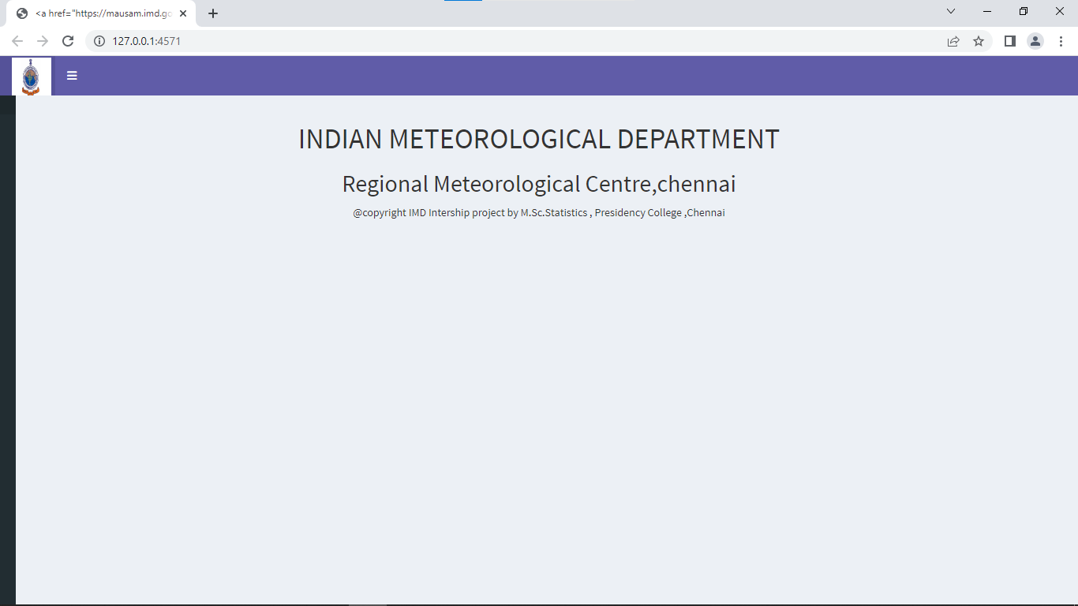

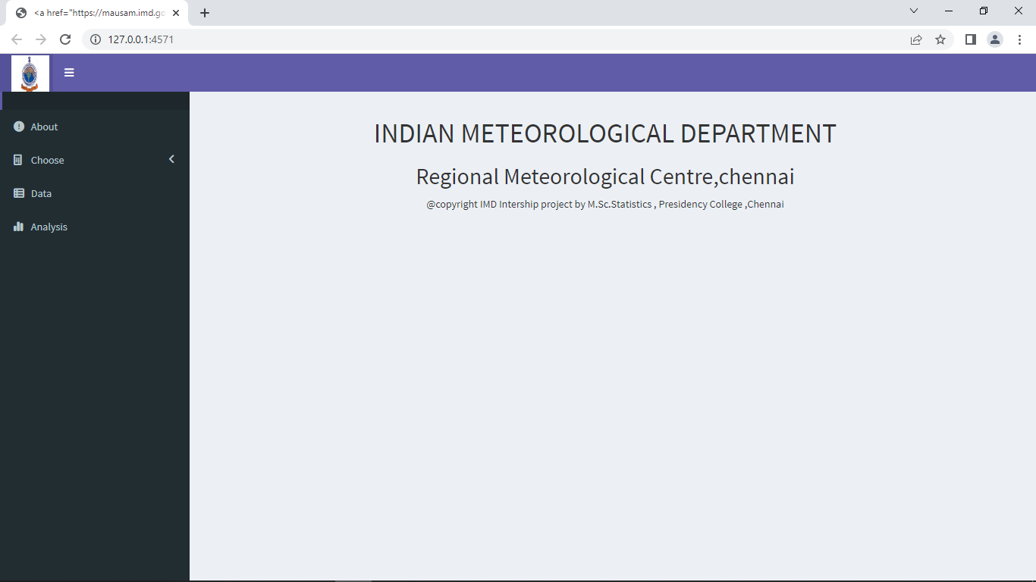

**ABOUT Section:**

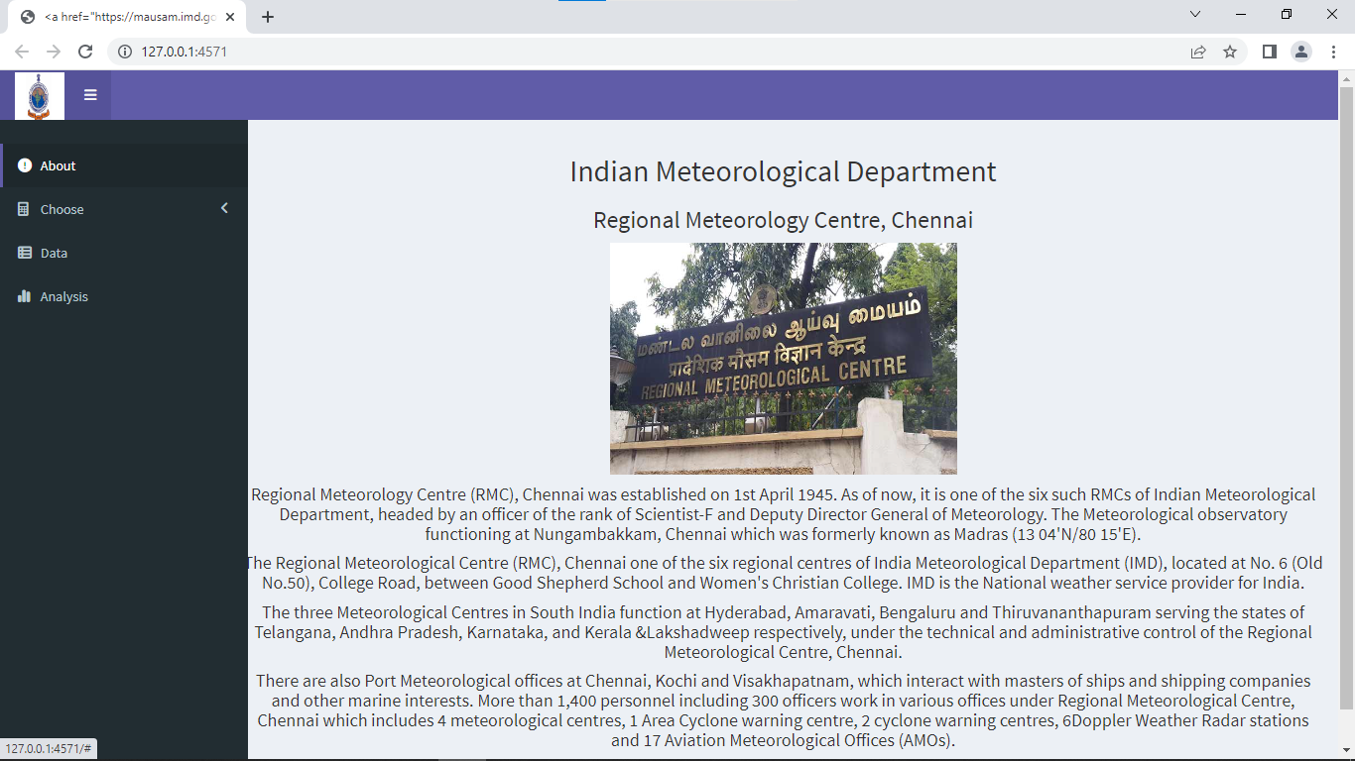

**CHOOSE Section:**

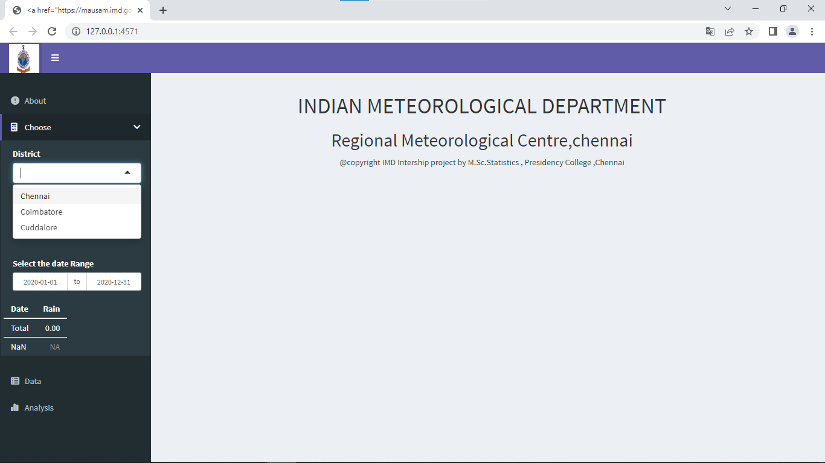District is choosen,

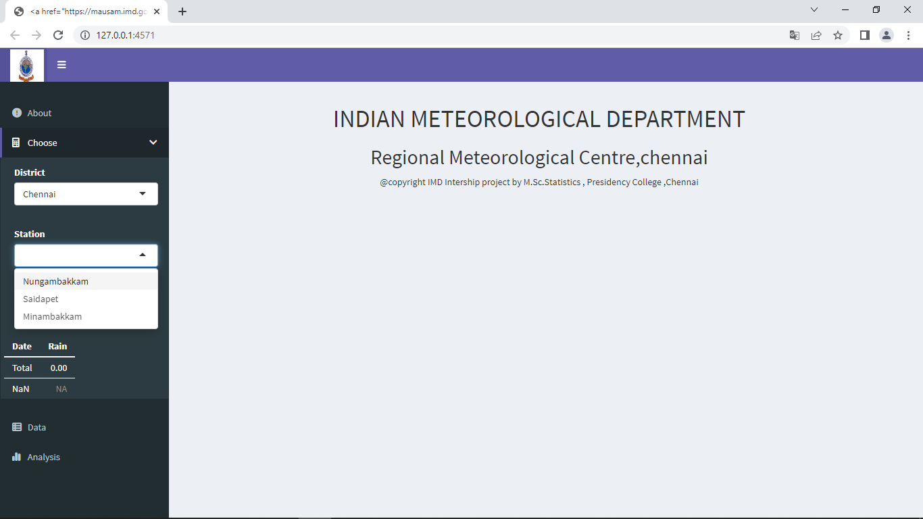Stations is updated after choosing district, now pick the Station

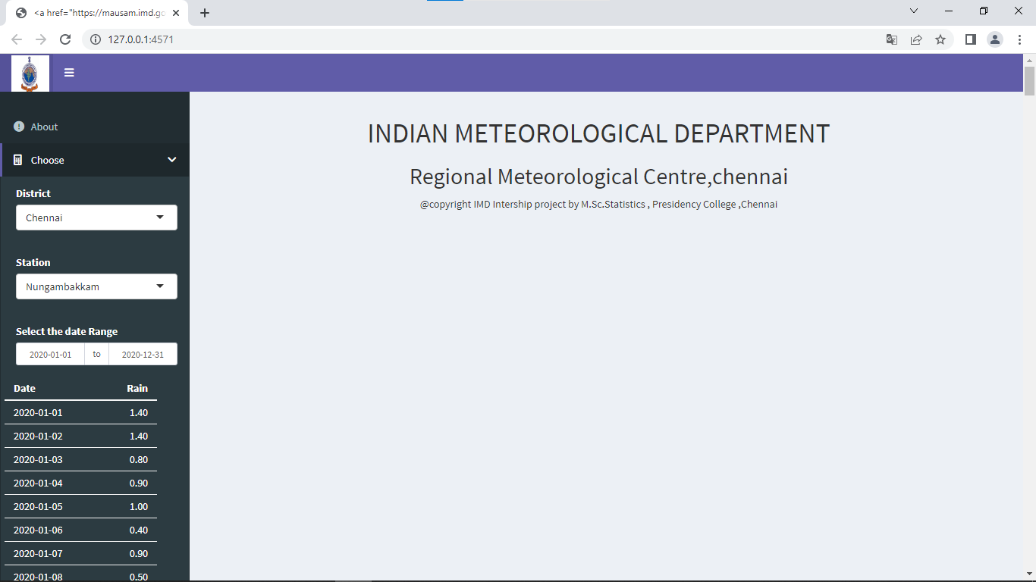Rainfall Data for the date range is render below,

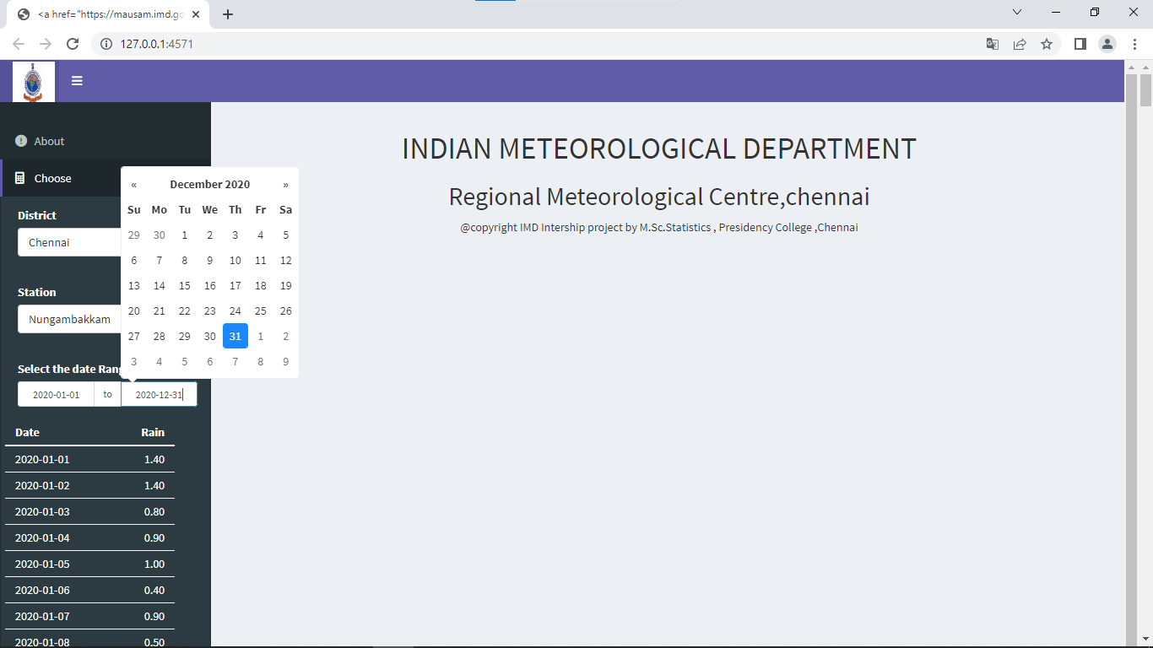 Date range is adjusted for particular dates.

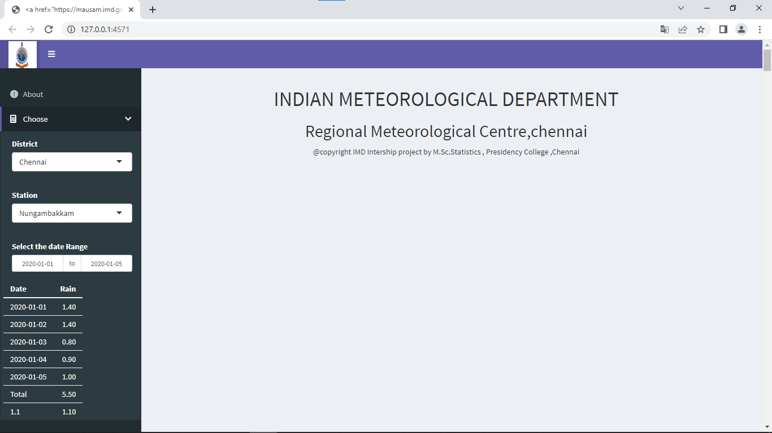Total and average rainfall of the selected date range is shown below the table

**DATA Section:**

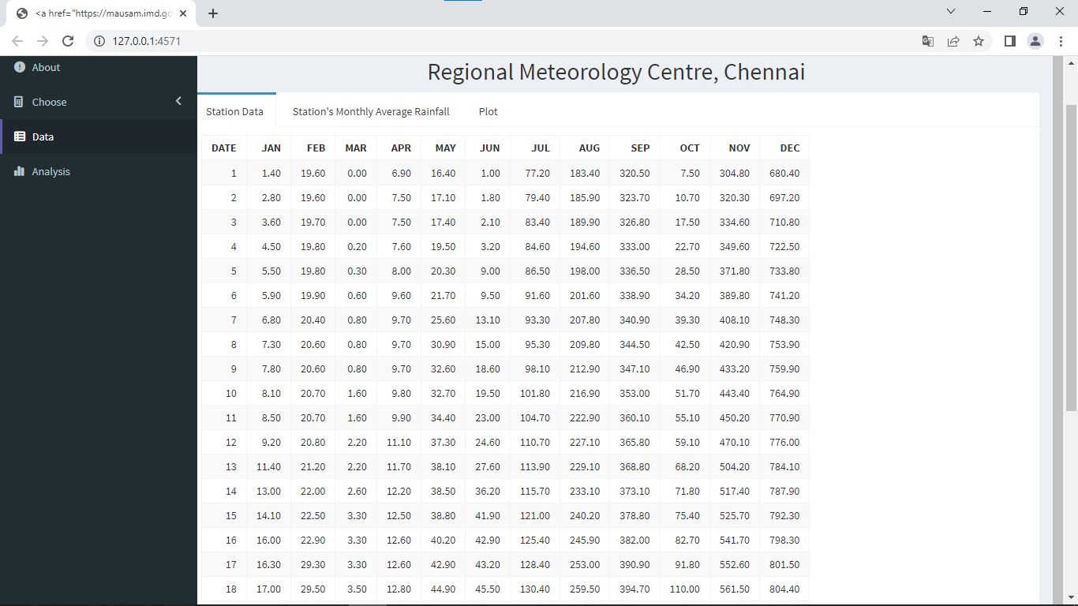Original rainfall Data given for the selected Station is rendered in this section.

Average Monthly Rainfall of the selected Station is rendered here:

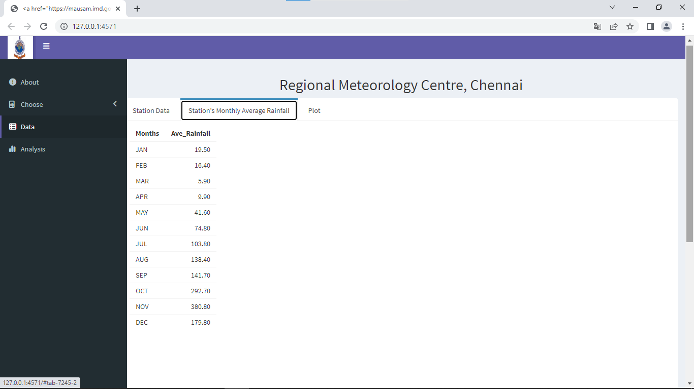

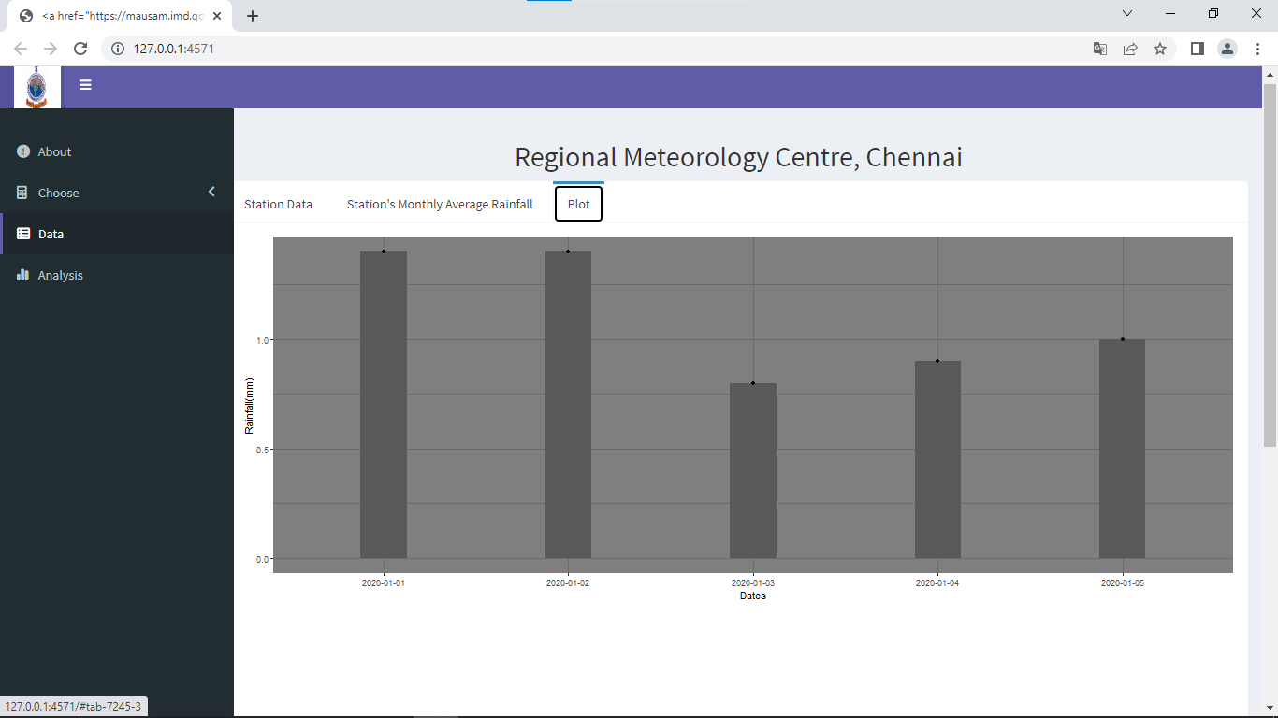Bar graph is plot for the rainfall of the spcified dates is shown here:

**ANALYSIS Section:**

ANOVA and its summary is rendered here: 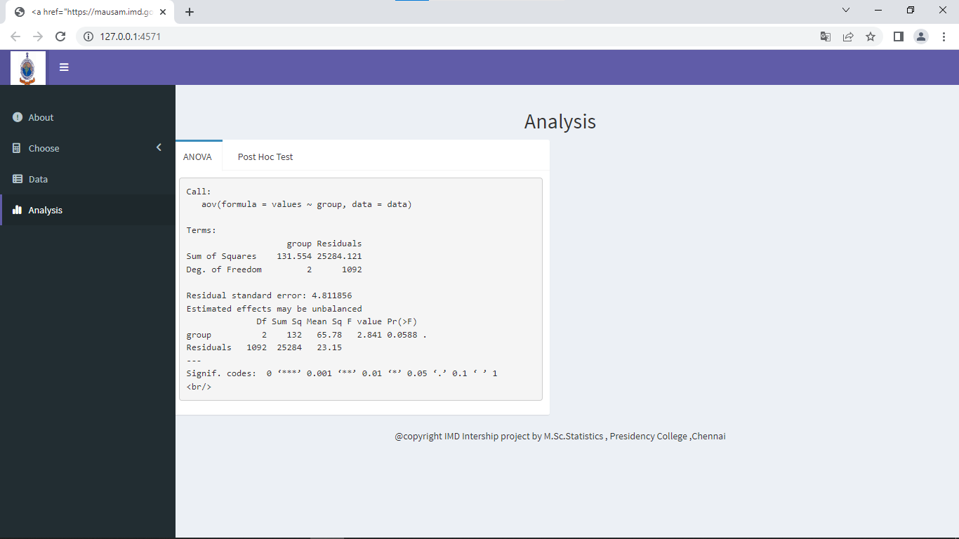

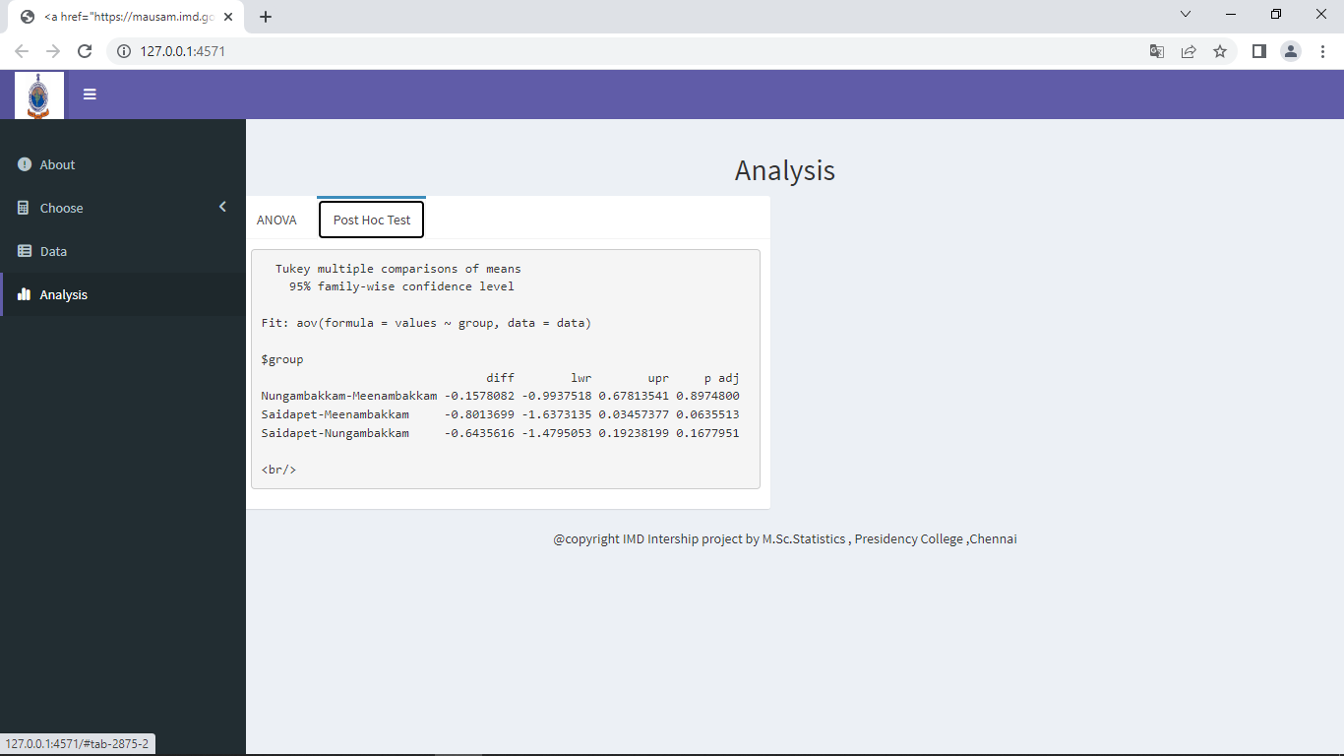Post Hoc test Summary

i.e, Turkey’s HSD test reslt will be rendered here:

***INTERNSHIP STUDY***

From this we learned the functioning and works of IMD RMC Chennai and how the rainfall is being recored using different measurements, wind speed and direction is noted etc,.On statistical basis, we learned how to handle large data. To add something new we were able to know about R program further and the extension R shiny. Though we stuggled a lot to learn earlier but its being managed.

***BIBLIOGRAPHY***

<https://mausam.imd.gov.in/>

<https://mausam.imd.gov.in/chennai/>

<https://www.wikipedia.org/>

<https://www.tutorialspoint.com/r/index.htm>

<https://shiny.rstudio.com/>

<https://cran.r-project.org/package=shiny>

<https://community.rstudio.com/c/shiny/8>

<https://github.com/rstudio/shiny>

<https://www.geeksforgeeks.org/shiny-package-in-r-programming/#:~:text=Shiny%20is%20an%20R%20package,%2C%20htmlwidgets%2C%20and%20JavaScript%20actions>.

<https://towardsdatascience.com/beginners-guide-to-creating-an-r-shiny-app-1664387d95b3>